Superior University / BSDS – Semester 2
Course Assignment: Generative AI
OBE-Based Problem Based Learning (PBL) Assignment
Program: BS Artificial Intelligence / BS Data Science
Semester: 2nd Semester
Course Title: Generative AI
Instructor name: Aleena Aslam
Assignment Type: Individual Practical Assignment Done

Name: Muhammad Umar shah

Roll No: {058}

Section: {BSDS – 2A}

Semester: BSDS 2nd

Subject: Generative AI Assignment No {1}

Date: 19-04-2026
Assignment Title:
Task 1:
AI-powered portfolio website
Task 2:
A. Prompt You Gave to ChatGPT
Create a modern AI Portfolio Website with a responsive frontend and full backend integration using APIs. It should include login/signup authentication, a user profile page, and a home page with featured projects and skills. Build at least 4 pages: Home, Profile, Projects, Contact, and Location (map integration). Add a secure admin panel with role-based access to manage users, projects, and contact messages. The backend should use REST APIs with a database, JWT authentication, password hashing, and file upload support. The system should be scalable, secure, and deployment-ready.
Task 3:
B. Final Prompt Generated by ChatGPT
Create a full-stack AI-powered portfolio website for "Muhammad Umar Shah", an AI/ML Developer specializing in Python and Django.

TECH STACK:
Frontend: HTML, CSS, JavaScript (modern UI, dark theme, smooth animations)
Backend: Python Django
Database: SQLite (default Django DB)
API: REST API using Django REST Framework

CORE FEATURES:

1. AUTHENTICATION SYSTEM:
- User signup/login/logout
- Secure authentication with sessions
- Admin panel login (Django admin)
- Role-based access (Admin/User)

2. PAGES (MINIMUM 4 + MORE):
- Home Page:
- Hero section (name, tagline: "Join the Radl World")
- Skills (AI, ML, Python, Django)
- Animated stats
- Featured projects preview

- About Page:
- Full bio
- Skills with progress bars
- Experience timeline

- Projects Page:
- Dynamic projects loaded from database
- Each project has: title, description, image, GitHub link

- Contact Page:
- Contact form (name, email, message)
- Save messages to database
- Show location map (Pakistan)
- Social links

- Profile Dashboard (Protected):
- User profile info
- Edit profile
- Uploaded projects
- Activity history

3. ADMIN PANEL:
- Manage users
- Add/edit/delete projects
- View contact messages
- Dashboard analytics (basic counts)

4. API FEATURES:
- API endpoint for projects (/api/projects/)
- API endpoint for users (/api/users/)
- API endpoint for contact messages
- JSON responses

5. EXTRA ADVANCED FEATURES:
- AI chatbot assistant on homepage (basic rule-based or OpenAI API ready)
- Dark modern UI like futuristic theme
- Responsive mobile-friendly design
- SEO optimized
- Loading animations
- Navbar with smooth scrolling

6. BACKEND STRUCTURE:
- Django apps:
- accounts (auth system)
- projects (portfolio)
- core (home, about, contact)
- Models:
- User (extended)
- Project
- ContactMessage

7. SECURITY:
- CSRF protection
- Form validation
- Login required decorators

8. DEPLOYMENT READY:
- Prepare for deployment on Vercel or Render
- Static files configured
- .env support for API keys

OUTPUT REQUIRED:
- Full Django project structure
- All HTML templates
- CSS styling (modern)
- JS scripts
- Models, views, urls
- API serializers
- Instructions to run locally

BONUS:
- Add "StormPhonk" style branding
- Add motivational quotes sections
- Add animation like typing effect

Task 4:
Generate Website Using Any AI Tool
- Replit
I Use This One For My Website Of AI:
Task 5:
Required Screenshots
Screenshot 1: ChatGPT properly presenting the user ID
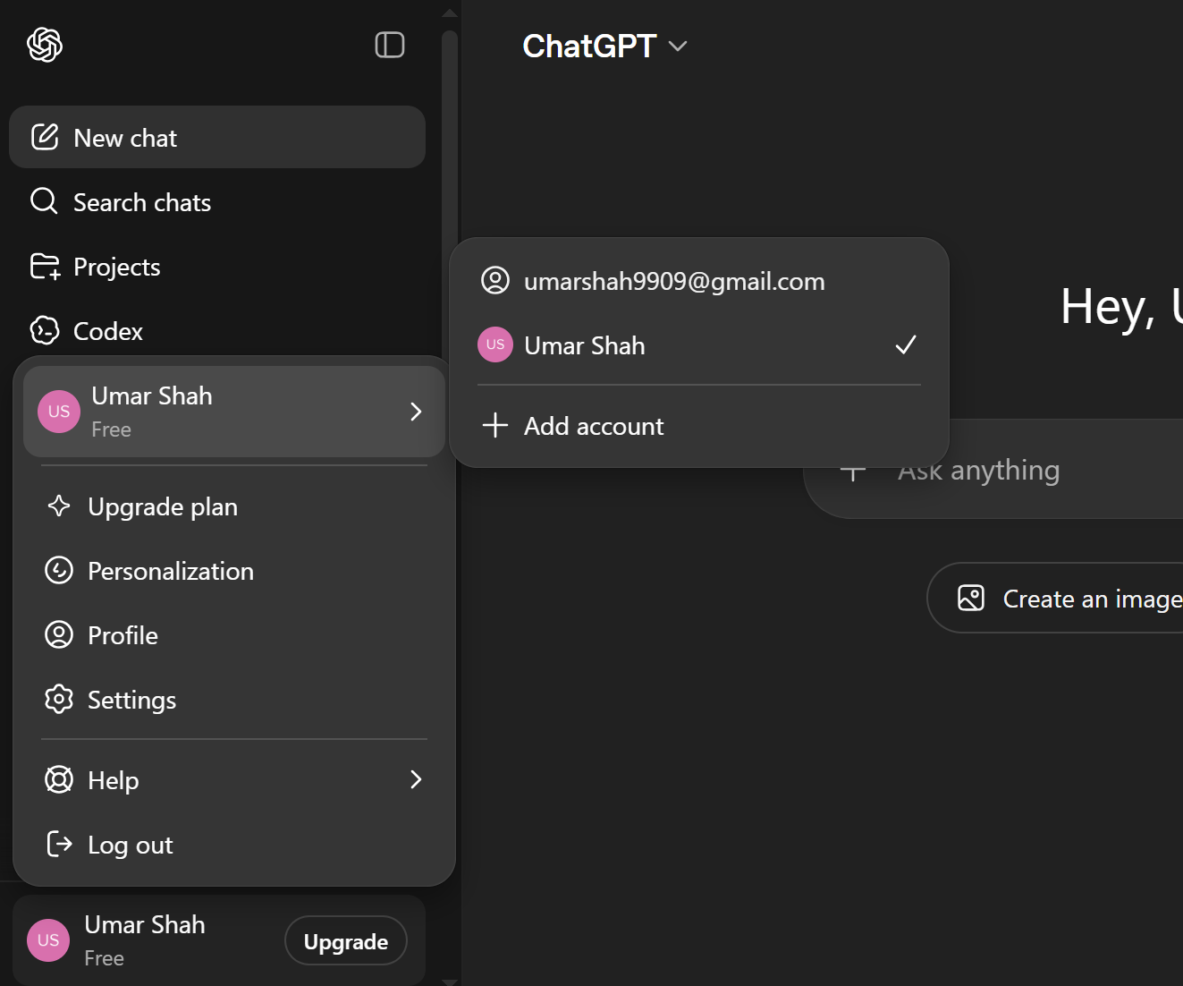

Screenshot 2: Chatgpt creating the prompt showing your user ID
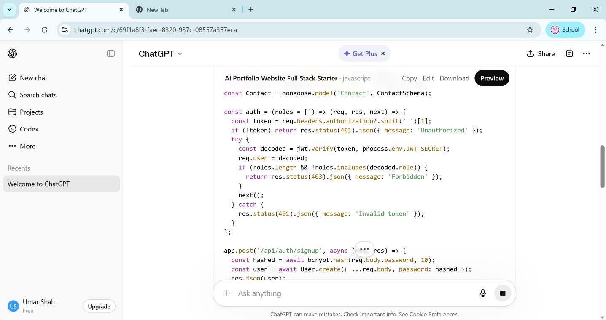

Screenshot 3: the AI tool in which you enter the generated new prompt
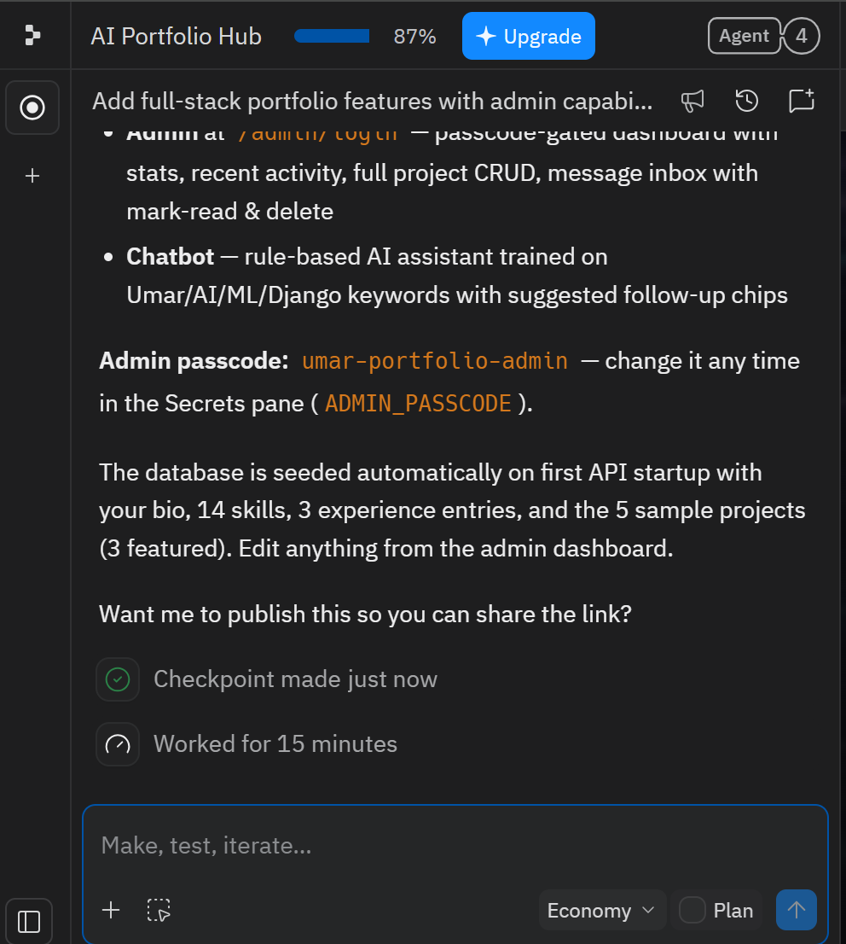

Screenshot 4: The AI generating website process
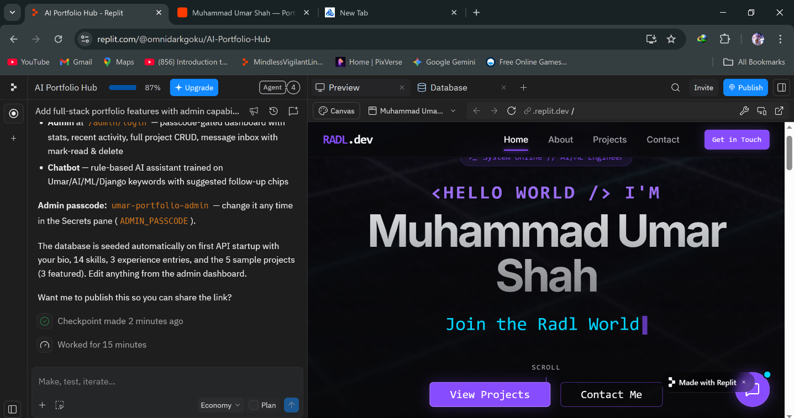

Screenshots: presenting your whole website
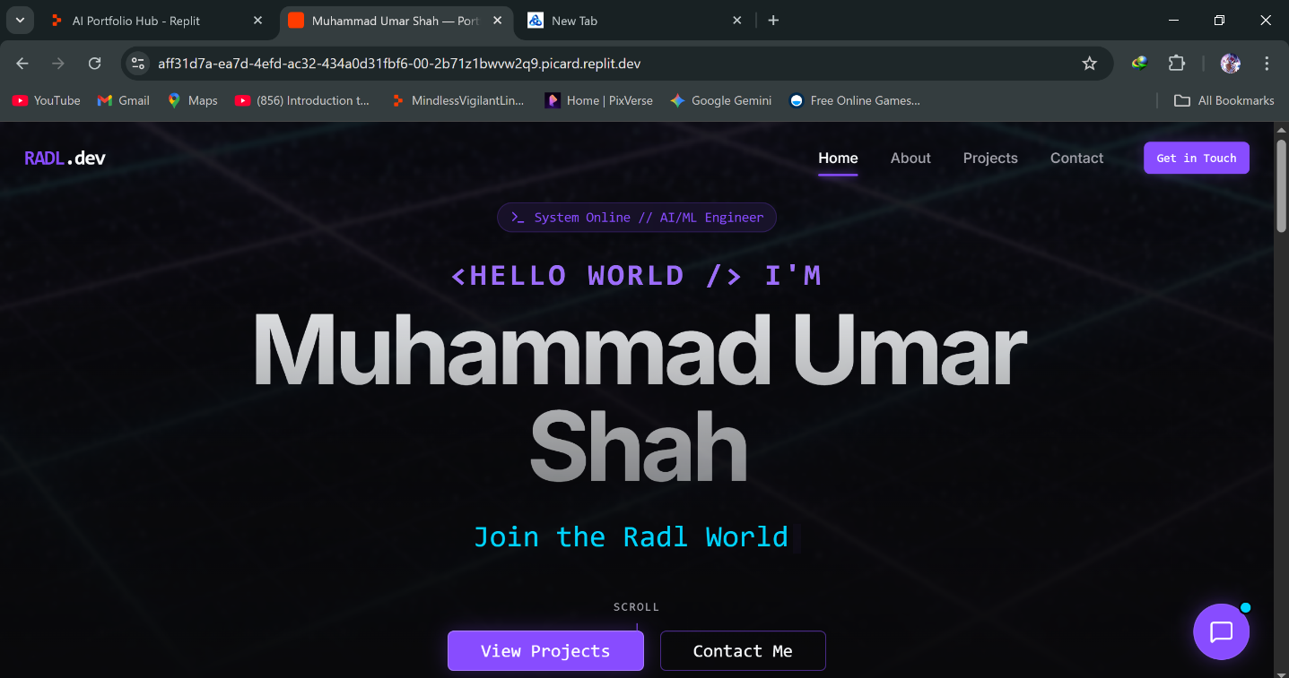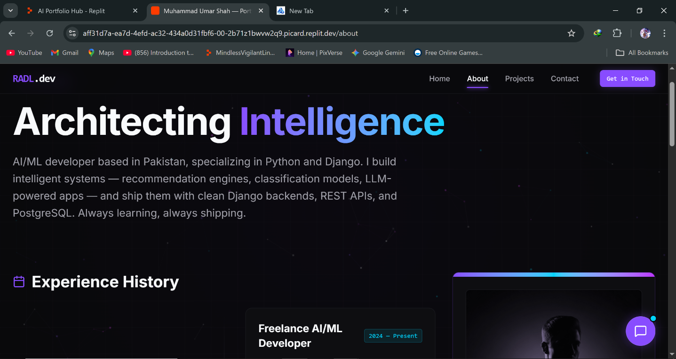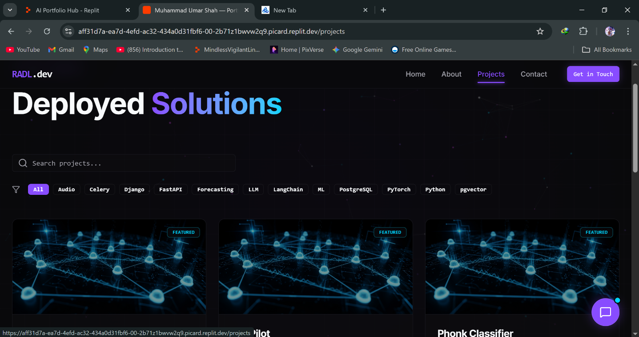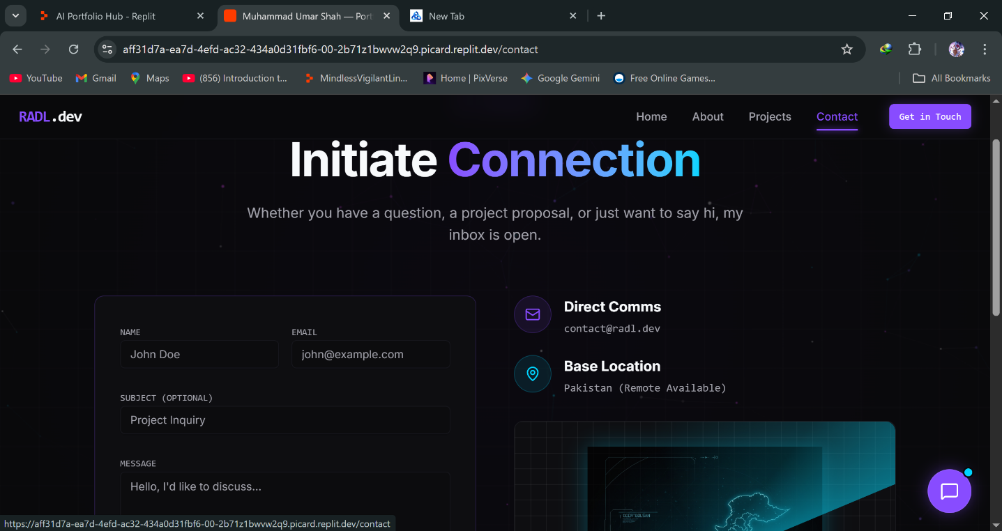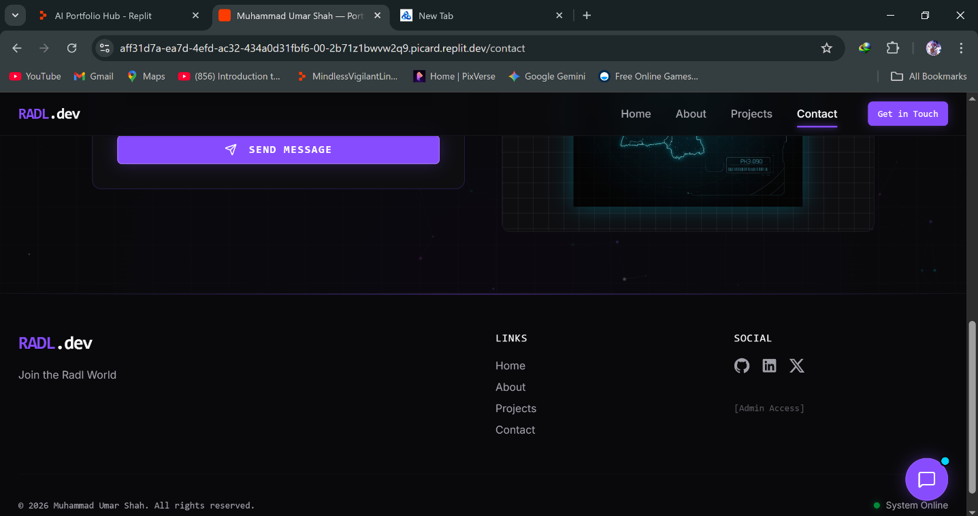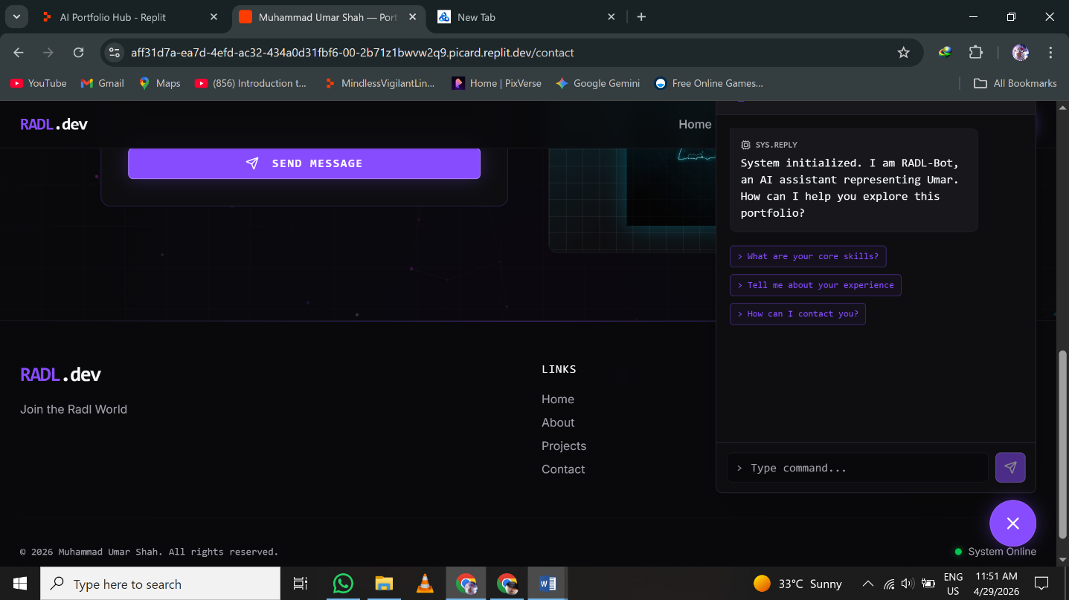
Task 5: Link of your website!
Paste your generated website live link.
https://ai-portfolio-hub--omnidarkgoku.replit.app
Disclaimer:
All content, ideas, and work presented here are created by me. I take full responsibility for everything shown. This is shared for informational and educational purposes. I use two different IDs for my work: one for prompt creation and another for AI website development on Replit. Thank you.
The End

